**Thato Sebelemetja**

**Student Number: 10067544**

**PATHWAY: CLDV6212**

**Lecturer: Isaac Leshaba**

**20 November 2023**

**Cloud Development B POE**

**Table of Contents:**

Question A: 3

Question B: 3

Screenshots: 4

- The Function Code: 4

- 5 Messages in the queue: 5

- Corresponding Messages in the database: 5

Question D: 6

REFERENCES: 7

# Question A:

|  |  |  |
| --- | --- | --- |
| Component | Technology Choice | Hosting Model |
| Azure Function | Compute | Serverless |
| Azure Storage Queue | Data Storage | PaaS |
| Azure SQL Database | Data Storage | PaaS |

# Question B:

The component that I will be changing to meet the primary requirements of Aweh Productions is the data storage component. Specifically, I will be changing the data storage of the Azure SQL Database to Azure Cosmos DB due to fact that if I change this component, it will tackle both the speed, cost and different format requirements all at once.

Unlike Azure SQL Database, Azure Cosmos DB is designed for low-latency, real-time access to data and offers the bonus of high scalability. It supports multiple consistency models, allowing you to tune the retrieval speed of data based on your requirements. This makes it ideal for Aweh Productions because they require fast retrieval of vaccination information.

Also, Azure Cosmos DB supports a variety of NoSQL data models and query languages, such as MongoDB, Cassandra, etc. Meaning this allows for data to be stored and retrieved in different formats with optimal efficiency whilst using a cost-effective pricing model which scales automatically based on demand.

# Screenshots:

# The Function Code:

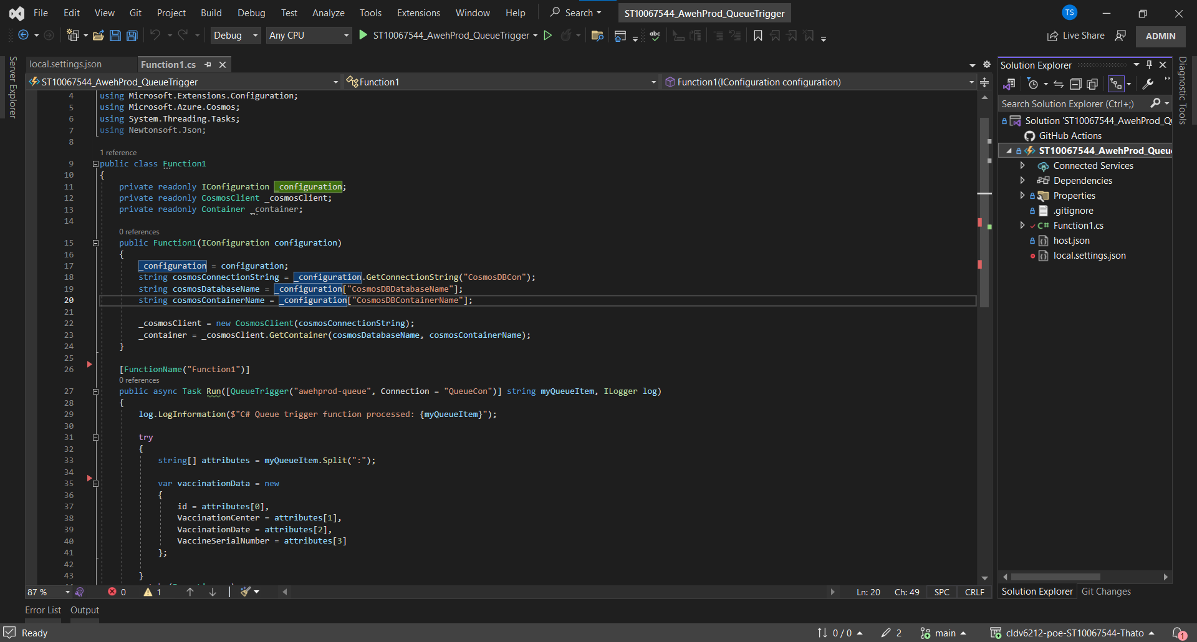

# 5 Messages in the queue:

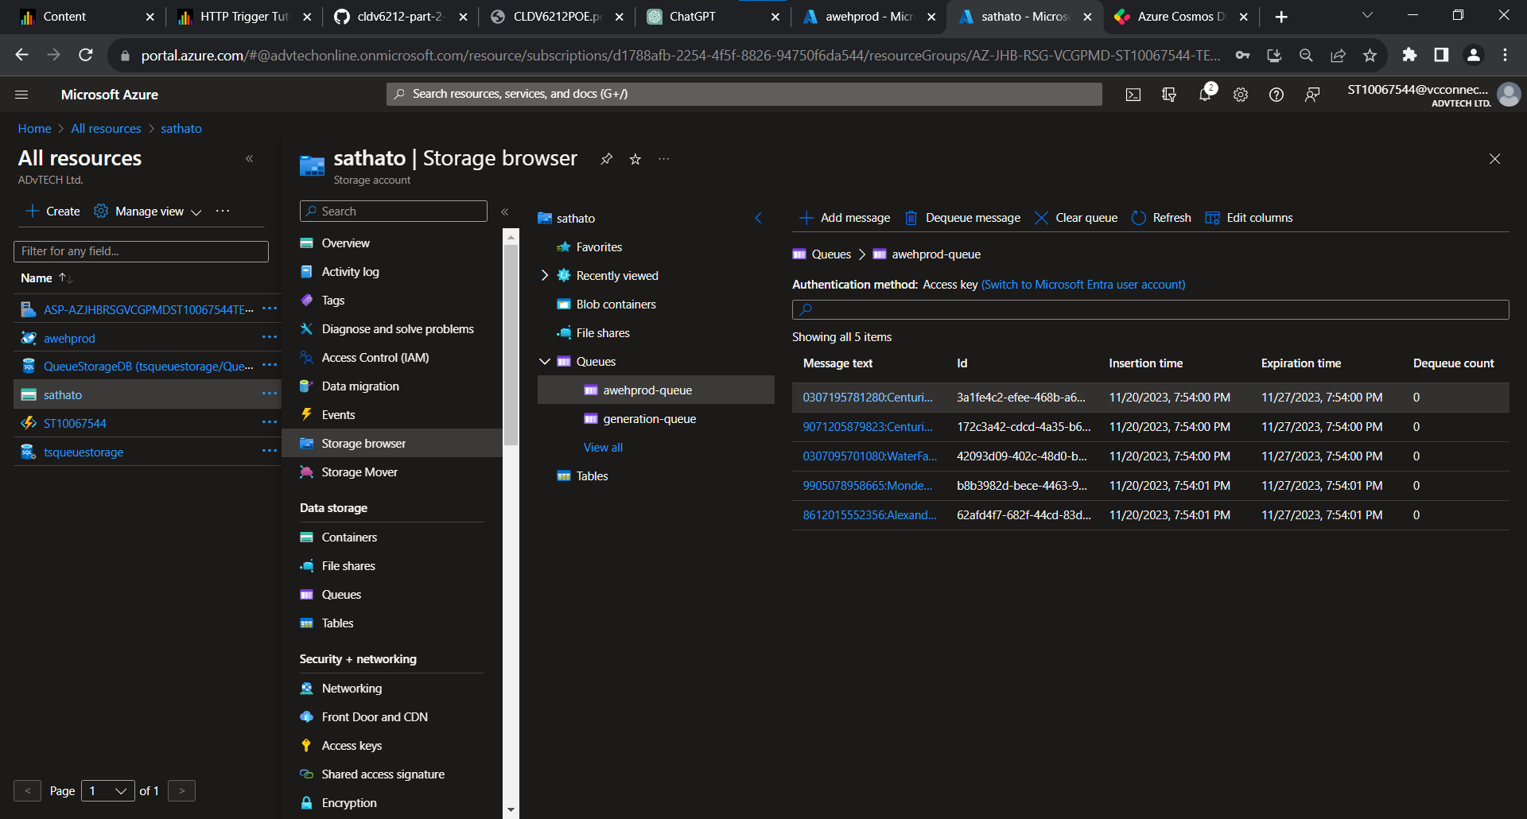

# Corresponding Messages in the database:

# Question D:

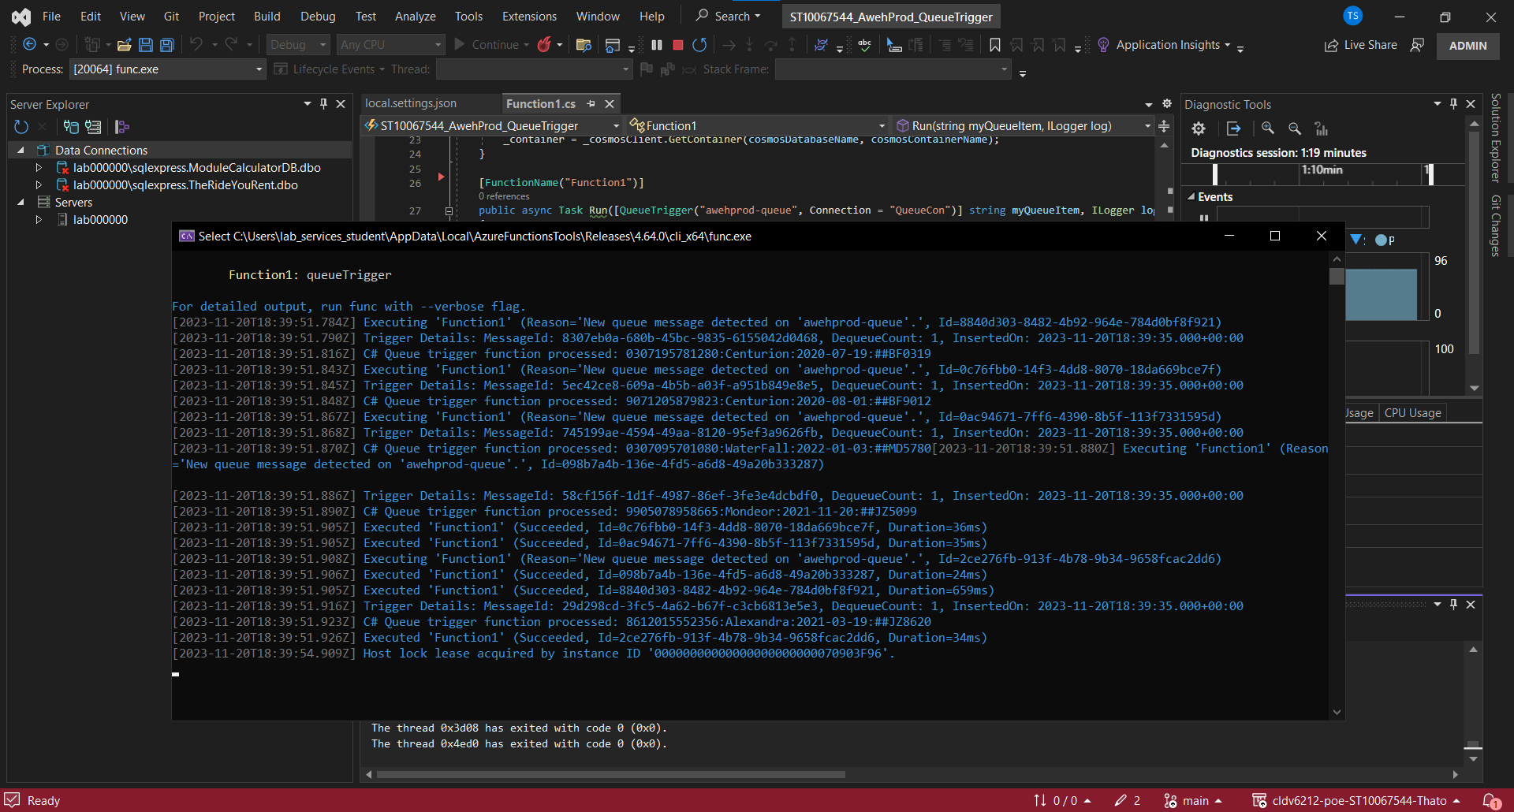

# REFERENCES:

ggailey777 (2023). *Azure Functions Overview*. [online] learn.microsoft.com. Available at: <https://learn.microsoft.com/en-us/azure/azure-functions/functions-overview?pivots=programming-language-csharp/> [Accessed 20 Nov. 2023].

‌intercept.cloud. (n.d.). *Top 5 Azure Paas and serverless services you don’t want to miss as an ISV*. [online] Available at: <https://intercept.cloud/en/news/top-5-azure-paas-and-serverless-services-you-dont-want-to-miss-as-an-isv/> [Accessed 20 Nov. 2023].

‌Bhatt, S. (2023). *Azure Cosmos DB vs. Azure SQL Database: Which One is Right for Your Data Needs?* [online] The Tech Guy. Available at: <https://the-tech-guy.in/2023/04/14/azure-cosmos-db-vs-azure-sql-database/#:~:text=Cosmos%20DB%20is%20an%20ideal/> [Accessed 20 Nov. 2023].